IMDB Movie Review Exploratory Data Analysis & Sentiment Analysis using Logistic Regression

Farah Husna binti Roslan   
Faculty of Computer & Electronic Engineering  
Universiti Teknikal Malaysia MelakaMalaysia  
b022010037@student.utem.edu.my

Idzwan Yusri bin Idris  
Faculty of Computer & Electronic Engineering  
Universiti Teknikal Malaysia MelakaMalaysia  
b022010064@student.utem.edu.my Gan Aik Tong  
Faculty of Computer & Electronic Engineering  
Universiti Teknikal Malaysia MelakaMalaysia  
b022010005@student.utem.edu.my

Intan Nur Syafikah binti Kamarul Zaman  
Faculty of Computer & Electronic Engineering  
Universiti Teknikal Malaysia MelakaMalaysia  
b022010079@student.utem.edu.my

***Abstract* — This paper proposes an improved modeling approach for a system that automates analyzing movie reviews and categorizing them into positive and negative sets. The main contribution of this work is to analyze some of the essential studies done so far and to provide an overview of sentiment analysis (SA) models in emotion AI-driven SA. The sentiment analysis is used to determine the exactness of the underlying emotion in the context of movie reviews to help users decide if the movie is worth their time. The quantization and prediction of the sets can be achieved with the utilization of the logistic regression method and natural language processing together with accuracy. Therefore, the process of understanding, if a review is positive or negative, can be automated as the machine learns through training and assessing the data. To validate the accuracy of the proposed model, four performance metrics of distinct types (F1-score, Recall, Precision, and confusion matrix) from various contexts are tested with Python code which works perfectly together with commented lines. The classified NLTK (Natural language toolkit) results are further stored in the structures that could be iterated while calling for visualization. It was found that the proposed model is superior when subjected to positive and negative review variations. In particular, the model matches very accurately for all important reviews for the sentiment analysis, with 88.7% accuracy based on the machine learning approach. The modeling method is useful for rating how positive or negative a movie review is and hence the overall rating for a movie. A summary of all reviews for a movie can help users make this decision by not wasting their time reading all reviews.**

Keywords — sentiment analysis, logistic regression, natural language processing, accuracy, machine learning, performance metrics.

# Introduction

IMDB is a large online database platform for films, TV shows, home videos, video games, and streaming content that includes information about the cast, production crew, personal biographies, plot summaries, trivia, ratings, and reviews. By using real-time data from IMDB and analyzing it using natural language processing and machine learning, sentiment analysis can be performed to predict the emotion, attitude, or personality of a person as expressed in different aspects. However, with the vast number of internet users, it is not efficient for big companies to manually analyze millions or billions of reviews by humans. In short, the problem statement includes that there are too many reviews for a human being to analyze within a specific time. With the help of artificial intelligence, we can automatically simplify the movie review to ease us to decide if the movie is worth watching.

Data is a valuable resource today, and social media sites contain a lot of information about people, including their thoughts. This has led to extensive research by companies and organizations to better understand people's needs. User views on social media platforms can be considered as sentiments and are analyzed by tech companies and scholars using approaches like the Naive Bayes method, linear regression, and deep learning algorithms. Twitter is a platform for sharing and communication through tweets that was founded in 2006. Twitter, with almost 500 million clients and millions of messages every day has quickly become an important resource for companies to monitor their reputation and brands by analyzing tweets about their products, services, advertising, and competitors. Twitter is a rich source of data for sentiment analysis, with tweets being categorized as positive, negative, or neutral. Our main gap between Twitter sentiment analysis is that twitter mainly focuses on tweet sentiment while we are more focused on movie review sentiment since there are very rare movie review applications out there.

The main objective of sentiment analysis is to accurately extract people's opinions from many unstructured review texts and classify them into sentiment classes, positive or negative. Instigated by the way of this, the study executed by us is to use sentiment evaluation to display the general mood of the people and hit upon the opinions and feelings of the people about the review of a specific movie. Initially, knowledge or opinions were shared among family members, neighbors, friends, relatives, etc. in person. Now, with the evolution of technology, most of these exchanges happen online where SA plays a significant role. Technology has provided a platform for one to be exposed to thousands of opinions in minutes. Human language is difficult to be understood by machines, thus it calls for the need for Natural Language Processing. It is a branch of artificial intelligence that helps to analyze, interpret, and evaluate human-understandable data into machine processing data. NLP and information extraction (IP) are the two approaches to which sentiment analysis can take advantage to analyze users’ sentiments.

The rest of this paper is organized as follows: Section II describes the general theory of Natural Language Processing, Sentiment Analysis, Machine Learning, Logistic Regression, Computer Vision and Pattern Recognition. Section III elaborates on the proposed predictive modeling which includes the methodology and approaches for data processing, training, and testing while in Section IV, the results and discussion are depicted whereas Section V draws the conclusion and suggests the direction of future work.

# Theory

## Natural Language Processing (NLP)

Natural Language Processing (NLP) is a field of artificial intelligence that focuses on enabling computers to understand, interpret, and generate human language. It involves using computers to process and analyze large amounts of natural language data and to generate intelligent responses to user inputs. There are many different approaches to NLP, including rule-based systems, statistical models, and machine-learning techniques. Some common tasks in NLP include language translation, text summarization, sentiment analysis, and entity recognition. To perform these tasks, NLP algorithms often rely on techniques from linguistics, computer science, and statistics. They may use dictionaries, grammar, and other language resources to analyze and interpret the meaning of words and sentences, and they may use machine learning techniques to automatically learn patterns in language data. Overall, the goal of NLP is to enable computers to process and understand human language in a way that is useful and effective for a wide range of applications.

## Sentiment analysis (or opinion mining)

Sentiment analysis, also known as opinion mining, is the process of using natural language processing and machine learning techniques to identify and extract subjective information from text. This can include determining the overall sentiment of a piece of text (positive, negative, or neutral), as well as identifying and extracting specific opinions and emotions expressed in the text. There are many different approaches to sentiment analysis, including rule-based systems, which use dictionaries and pre-defined rules to identify and classify words and phrases as positive or negative, and machine learning-based systems, which learn to classify text based on training data. One of the key challenges in sentiment analysis is the subjectivity of language. Words and phrases that might be considered positive by some people might be considered negative by others, and the same is true for negative words and phrases. As a result, it is important for sentiment analysis algorithms to be able to handle this subjectivity and to accurately identify and classify text based on the context in which it appears. Overall, the goal of sentiment analysis is to use natural language processing and machine learning techniques to automatically identify and extract subjective information from text, in order to better understand people's opinions and emotions.

## Machine Learning

Machine learning is a subfield of artificial intelligence that focuses on developing algorithms and statistical models that enable computers to learn from data, without being explicitly programmed. There are many different types of machine learning, including supervised learning, in which an algorithm is trained on labeled data and makes predictions based on this training data, and unsupervised learning, in which the algorithm is not given any labeled data and must find patterns and relationships in the data on its own. One of the key ideas behind machine learning is the concept of a model, which is a mathematical representation of a system or process. During the training process, the model is presented with a set of input data and corresponding desired output labels, and it adjusts its internal parameters to minimize the difference between the predicted output and the true output. Once the model has been trained, it can be used to make predictions on new, unseen data. Overall, the goal of machine learning is to enable computers to automatically improve their performance on a particular task through experience, without the need for explicit programming. This is achieved by using algorithms that can learn from data and adjust their internal parameters to optimize their performance.

## Logistic Regression

Logistic regression is a statistical model that is used for binary classification tasks, that is, tasks in which there are only two possible classes. It is a type of generalized linear model that is used to model the probability of a certain event occurring. In logistic regression, the output is a probability value between 0 and 1, which indicates the likelihood that an input belongs to a particular class. The logistic function, which is a sigmoid function, is used to map the input data to this probability value. The logistic regression model is trained using a set of input data and corresponding labels indicating the class of each input. The model adjusts its internal parameters, known as weights and biases, to minimize the difference between the predicted probability and the true class label. One of the key advantages of logistic regression is that it is a simple and efficient model that is easy to implement and interpret. It is widely used in a variety of applications, including predicting the probability of a customer churning or the likelihood of a patient having a particular disease. Overall, the goal of logistic regression is to use a statistical model to predict the probability of a binary outcome based on input data. It is a widely used and effective method for binary classification tasks.

## Computer Vision and Pattern Recognition

OCR, or optical character recognition, is a technology that enables computers to recognize and interpret the text that appears in images and videos. It is a type of pattern recognition that is specifically designed to recognize text characters, and it is often used to digitize printed documents, recognize text in images, and extract text from video. There are many different approaches to OCR, including rule-based systems, statistical models, and machine-learning algorithms. Some common techniques used in OCR include image pre-processing, which involves preparing the image for analysis by removing noise and correcting for distortion, and feature extraction, which involves identifying and extracting characteristics of the text that can be used to distinguish it from other elements in the image. One of the key challenges in OCR is the variability of text in terms of font, size, and style. To overcome this, OCR algorithms often use machine learning techniques to learn from a large dataset of annotated images and build a model that can accurately recognize text in a wide range of conditions. Overall, the goal of OCR is to enable computers to automatically recognize and interpret the text from images and video, to extract and digitize this information for further processing and analysis.

# Methodology

The main objective of SA is to obtain emotion from the context. The context might be data from an online review or document; it can be anything in a large amount where human beings could delay the process while dealing with it. There are 50002 total samples for us to test the machine learning algorithm. The training dataset consists of 50000 recorded data while the test dataset consists of 2 composite data. Our main idea is to develop a system that outperforms state-of-the-art methods to recognize and classify the sentiments from the recorded datasets, considering both understandable and non-understandable data. The proposed framework is based on NLP algorithms which reduce the complexity of the system to process the data.

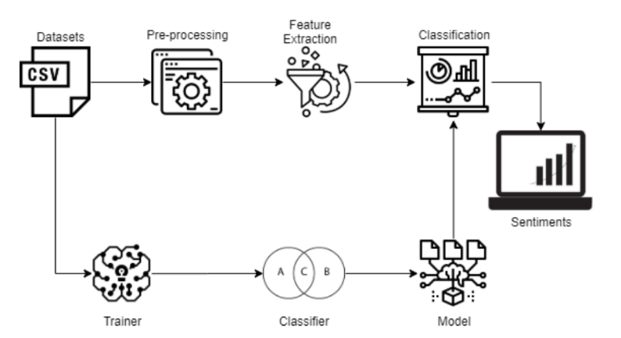

Figure 1: Flowchart Framework

## Datasets

Datasets of movie review text are entered into the training system in the form of an Excel CSV file while datasets consisting of the complex image are placed into test datasets. 50000 text data are used, and 2 complex images are used. The 2 complex images are then converted into text form by using Python OCR code.

## Trainer

Use machine learning techniques to train a classifier model on a labeled dataset, where the sentiment of the text has already been identified.

## Classifier

The classifier may be trained using a large dataset of movie reviews that have been labeled as positive, negative, or neutral.

## Model

The extracted features and a trained classifier model are used to predict the sentiment of the review.

## Pre-processing

Clean and prepare the data for analysis by removing unnecessary characters, correcting errors, and standardizing formatting. Tokenize data: Split the text into individual words or phrases (tokens) to prepare for analysis. Remove stop words: Remove common words such as "a," "the," and "and," which do not convey meaning and can interfere with the analysis.

## Feature Extraction

Identify the important features of the data, such as specific words or phrases, that will be used to analyze sentiment.

## Classification

Evaluate the performance of the classifier on a separate dataset to see how accurately it can predict sentiment. We use the trained classifier to analyze the sentiment of the collected data.

## Visualize Results

Present the results of the analysis in a clear and concise way, such as through graphs, tables and relevant performance metrics such as F1-score, Recall, Precision and confusion matrix

# Result & Analysis

The datasets for the initial processing can be gathered from the Internet. A sample of about 50,000 IMDB movies reviewed by people was analyzed. The extracted data was stored in a CSV or similar format which is the program's input. The Pandas library is used to import data into the data-frame from the CSV.

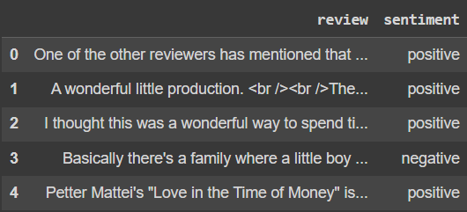

Table 1: Pre-processed data-frame

The data collected for analysis contains a lot of irrelevant information, such as hashtags, usernames (@), hyperlinks, emoticons (😊, 😐), etc. These symbols and words do not convey any meaning during the processing of data as they have nothing to do with sentiment analysis. The most common algorithms are contained in NLTK and these algorithms are such as tokenizing, grammatical form labelling, and stemming, The steps after the collection of data include breaking of data into tokens or segments, removing the stop words, and performing the stemming so that it can be easily processed. For this purpose, various functions from the Natural Language Toolkit (NLTK) Module are used. With the help of this module, the data of reviews can be divided into words. This provides access to individual words from the data and analyses the relevance of these words in our sentiment analysis process. The dataset is then split into positive and negative sentiments. The visualization of positive and negative sentiment is shown.

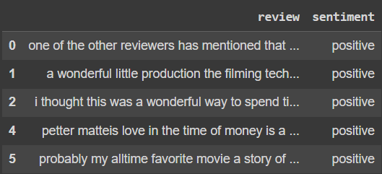  
  
Table 2: Positive sentiment

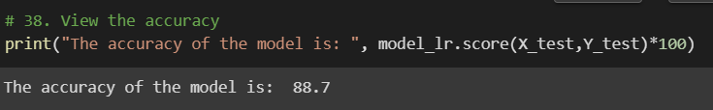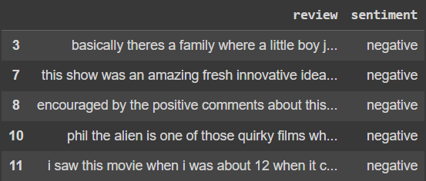

Table 3: Negative sentiment

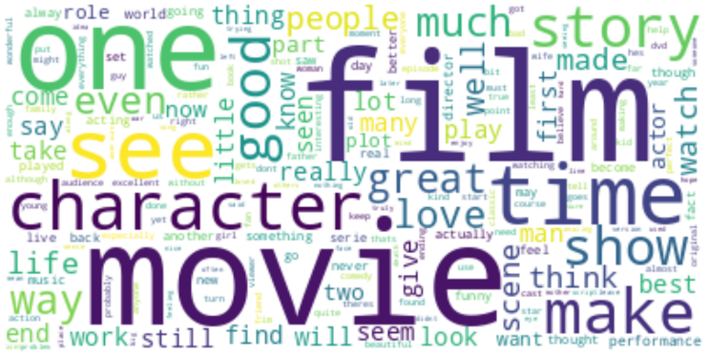

Figure 2: Visualization of positive sentiment

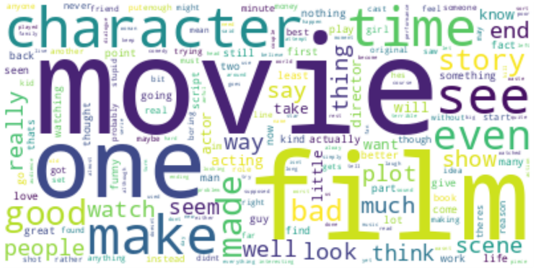

Figure 3: Visualization of negative sentiment

Accuracy, precision, recall, and F1 score are all evaluation metrics commonly used to measure the performance of a classifier, which is a machine learning model trained to predict the class of a given input. Accuracy is the fraction of correct predictions made by the classifier out of all predictions made. It is defined as the number of true positives (TP) and true negatives (TN) divided by the total number of samples, or: Accuracy = (TP + TN) / total Precision is the fraction of correct positive predictions made by the classifier out of all positive predictions made. It is defined as the number of true positives divided by the sum of the true positives and false positives (FP), or: Precision = TP / (TP + FP) Recall is the fraction of correct positive predictions made by the classifier out of all actual positive samples. It is defined as the number of true positives divided by the sum of the true positives and false negatives (FN), or: Recall = TP / (TP + FN) F1 score is a measure of a classifier's balance between precision and recall. It is defined as the harmonic mean of precision and recall, or: F1 score = 2 * (precision * recall) / (precision + recall) A classifier with high accuracy, precision, and recall is a strong performer, while a classifier with low values for these metrics may indicate a need for improvement.

Figure 4: Accuracy of the trained model

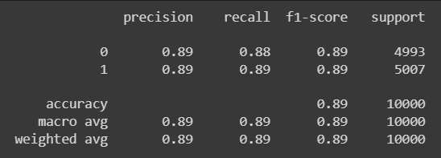  
  
Table 4: Classification report

A confusion matrix is a table that is used to evaluate the performance of a classifier by comparing the predicted classes with the true classes of a dataset. It is often used in conjunction with evaluation metrics such as accuracy, precision, and recall. The rows of the confusion matrix represent the actual classes, the columns represent the predicted classes, and the values in the cells represent the number of samples that fall into each combination of actual and predicted classes. For example, a confusion matrix for a binary classifier might have values for true positives, false positives, true negatives, and false negatives in the cells of the matrix.

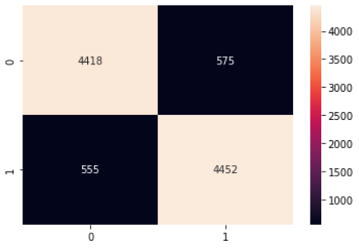

Figure 5: Confusion matrix

A test dataset is a collection of data that is used to evaluate the performance of a machine-learning model. It is typically used to verify that the model has learned to make accurate predictions on new, unseen data. A test dataset may consist of both good and bad reviews to provide a diverse and representative sample for testing. By comparing the model's predictions to the true labels of the test dataset, it is possible to assess the model's performance and improvement.



Figure 6: Test dataset of good review

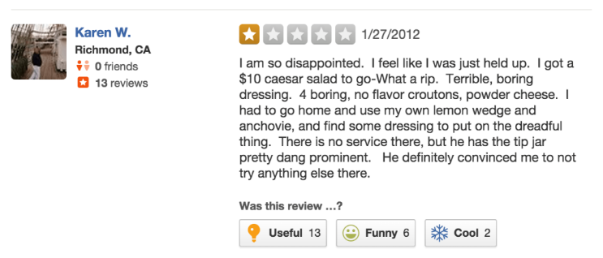

Figure 7: Test dataset of bad review

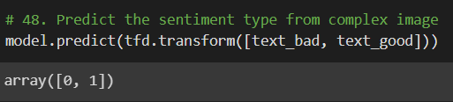

Figure 8: Output identification by the trained model

# Discussion & Conclusion

This paper presents a detailed AI model to analyze current state-of-the-art approaches for reviewing emotion recognition in static images and various parameters that influence the results of these approaches. Also, this report reviewed the merits, demerits, and scope of the different approaches that have been considered. A significant advantage of sentiment analysis is that it provides the exact emotion that is underlined in the context. While performing the analysis, it has been observed that pre-processing the data using the regex and trainer has been an effective solution for clearing out the complexity of the applied algorithm as well as the data rather than directly applying it to the raw data itself. Using the trained model and further using it with the classifier proved to be a better way for classification as it reduced the size of the data frame reducing the time complexity involved in the process.

Currently, the model is trained to study and analyze the sentiments of people regarding their opinion on certain movies. We have compared various detection, extraction, and classification approaches and concluded which approach is more prominent in achieving better performance in available computation power. In short, our trained model is 88.7% accurate by using logistic regression. By comparing the predicted sentiments to the true sentiments of the reviews, we observed the performance of the model on a test dataset is well performed. Based on the results of this evaluation including the accuracy, precision, and recall of the model, as well as other evaluation metrics such as the F1 score, we can draw conclusions about the effectiveness of logistic regression for this specific task and identify potential areas for improvement.

The aspect-based ontology approach, SVM, and term frequency achieved high accuracy and provided better sentiment analysis results in the sample data. Future research directions and limitations were also discussed. While these results were high for the sample data, they may vary when applied to other applications. Deep learning approaches could also be compared in future work, which may significantly impact the results. This model could be made more user-friendly by scaling it up to analyze reactions and sentiments towards global events such as #blacklivesmatter. A system could be developed to store trained models for dummy datasets of these events, allowing users to upload their own datasets and filter results by their own keywords. By adding new keywords and improving the algorithm, the model's shortcomings can be identified and corrected for future use.

##### Acknowledgment

The authors would like to thank Universiti Teknikal Malaysia Melaka (UTeM), Centre for Telecommunication Research & Innovation (CeTRI) and Ministry of Higher Education (MOHE), Malaysia for sponsoring this work under project FRGS/2018/FKEKK-CERIA/F00363 and the use of the existing facilities to complete this project.

##### References

1. Ogul, H., Ekmekciler, E.: Two-way collaborative filtering on semantically enhanced movie ratings. In: The Proceedings of the ITI, pp. 361–366 (2012)
2. Lu, Y.; Kong, X.; Quan, X.; Liu, W.; Xu, Y. Exploring the sentiment strength of user reviews. In *International Conference on Web-Age Information Management*; Springer: Berlin/Heidelberg, Germany, 2010; pp. 471–482.
3. Yadollahi, A.; Shahraki, A.G.; Zaiane, O.R. Current state of text sentiment analysis from opinion to emotion mining. *ACM Comput. Surv. (CSUR)* 2017, *50*, 25.
4. Sarlan, C. Nadam and S. Basri, "Twitter sentiment analysis," Proceedings of the 6th International Conference on Information Technology and Multimedia, Putrajaya, 2014, pp. 212-216, doi: 10.1109/ICIMU.2014.7066632.
5. A. Pak,and P. Paroubek, “Twitter as a Corpus for Sentiment Analysis and Opinion Mining,” Special Issue of International Journal of Computer Application, France:Universitede Paris-Sud, 2010
6. D. Osimo, and F. Mureddu, “Research Challenge on Opinion Mining and Sentiment Analysis,” Proceeding of the 12th conference of Fruct association, 2010, United Kingdom.
7. Duwairi, R.; El-Orfali, M. A study of the effects of preprocessing strategies on sentiment analysis for Arabic text. *J. Inf. Sci.* 2014, *40*, 501–513.
8. Kaur, H.; Mangat, V. A survey of sentiment analysis techniques. In Proceedings of the 2017 International Conference on the I-SMAC (IoT in Social, Mobile, Analytics and Cloud) (I-SMAC), Palladam, India, 10–11 February 2017; pp. 921–925.
9. Annett, M.; Kondrak, G. A comparison of sentiment analysis techniques: Polarizing movie blogs. In *Conference of the Canadian Society for Computational Studies of Intelligence*; Springer: Berlin/Heidelberg, Germany, 2008; pp. 25–35.
10. Li, X.; Peng, Q.; Sun, Z.; Chai, L.; Wang, Y. Predicting Social Emotions from Readers’ Perspective. *IEEE Trans. Affect. Comput.* 2017, *10*, 255–264.
11. Cui, H.; Mittal, V.; Datar, M. Comparative experiments on sentiment classification for online product reviews. In Proceedings of the AAAI’06 Proceedings of the 21st National Conference on Artificial Intelligence, Boston, MA, USA, 16–20 July 2006; Volume 6, pp. 1265–1270.Khan, F.H.; Bashir, S.; Qamar, U. TOM: Twitter opinion mining framework using hybrid classification scheme. *Decis. Support Syst.* 2014, *57*, 245–257.
12. Khan, A.; Baharudin, B.; Khan, K. Efficient feature selection and domain relevance term weighting method for document classification. In Proceedings of the 2010 Second International Conference on the Computer Engineering and Applications (ICCEA), Bali Island, Indonesia, 19–21 March 2010; Volume 2, pp. 398–403.
13. Vinodhini, G., Chandrasekaran, R.: Sentiment analysis and opinion mining: a survey. Int. J. Adv. Res. Comput. Sci. Softw. Eng. 2(6), 282–292 (2012)
14. Rout, J.K.; Choo, K.K.R.; Dash, A.K.; Bakshi, S.; Jena, S.K.; Williams, K.L. A model for sentiment and emotion analysis of unstructured social media text. *Electron. Commer. Res.* 2018, *18*, 181–199.
15. Moh, M.; Gajjala, A.; Gangireddy, S.C.R.; Moh, T.S. On multi-tier sentiment analysis using supervised machine learning. In Proceedings of the IEEE/WIC/ACM International Conference on Web Intelligence and Intelligent Agent Technology (WI-IAT), Singapore, 6–9 December 2015; Volume 1, pp. 341–344.
16. Yue, L.; Chen, W.; Li, X.; Zuo, W.; Yin, M. A survey of sentiment analysis in social media. *Knowl. Inf. Syst.* 2019, *60*, 617–663.
17. Tripathy, A.; Agrawal, A.; Rath, S.K. Classification of sentimental reviews using machine learning techniques. *Procedia Comput. Sci.* 2015, *57*, 821–829.
18. Medhat, W.; Hassan, A.; Korashy, H. Sentiment analysis algorithms and applications: A survey. *Ain Shams Eng. J.* 2014, *5*, 1093–1113.
19. Yue, L.; Chen, W.; Li, X.; Zuo, W.; Yin, M. Survey on target dependent sentiment analysis of micro-blogs in social media. In Proceedings of the 9th IEEE-GCC Conference and Exhibition, GCCCE, Manama, Bahrain, 8–11 May 2017; p. 1.
20. Wang, J., Liu, T.: Improving sentiment rating of movie review comments for recommendation. In: The IEEE International Conference on Consumer Electronics—Taiwan, ICCE-TW 2017, pp. 433–434 (2017)
21. Gupte, A.; Joshi, S.; Gadgul, P.; Kadam, A.; Gupte, A. Comparative study of classification algorithms used in sentiment analysis. *Int. J. Comput. Sci. Inf. Technol.* 2014, *5*, 6261–6264.
22. Che, W.; Zhao, Y.; Guo, H.; Su, Z.; Liu, T. Sentence compression for aspect-based sentiment analysis. *IEEE/ACM Trans. Audio Speech Lang. Process. (TASLP)* 2015, *23*, 2111–2124.
23. Singh, V.K.; Piryani, R.; Uddin, A.; Waila, P. Sentiment analysis of Movie reviews and Blog posts. In Proceedings of the 2013 3rd IEEE International Advance Computing Conference (IACC), Ghaziabad, India, 22–23 February 2013; pp. 893–898.
24. A. Gelbukh, "Natural language processing," Fifth International Conference on Hybrid Intelligent Systems (HIS'05), Rio de Janeiro, Brazil, 2005, pp. 1 pp.-, doi: 10.1109/ICHIS.2005.79
25. Li, J., Xu, W., Wan, W., Sun, J.: Movie recommendation based on bridging movie feature and user interest. J. Comput. Sci. 26, 128–134 (2018)
26. Pak, A., Paroubek, P.: Twitter as a Corpus for sentiment analysis and opinion mining in the computer, pp. 1320–1326 (2010)
27. Ng, A.Y., Jordan, M.I.: On discriminative versus generative classifiers: a comparison of logistic regression and Naive Bayes. In: Advances in Neural Information Processing Systems, pp. 841–848 (2002)
28. Alsabti, K., Ranka, S., Singh V.: CLOUDS: tree classifier for large datasets. In: The Proceedings of the Fourth Knowledge Discovery and Data Mining Conference, pp. 2–8 (1998)
29. Yadav, S.P. and Yadav, S., 2020. Image fusion using hybrid methods in multimodality medical images. Medical & Biological Engineering & Computing, pp.1-19.
30. Yadav, S.P. and Yadav, S., 2020. Fusion of Medical Images in Wavelet Domain: A Hybrid Implementation. Computer Modeling in Engineering & Sciences, 122(1), pp. 303-321.
31. Denecke, K.; Deng, Y. Sentiment analysis in medical settings: New opportunities and challenges. *Artif. Intell. Med.* 2015, *64*, 17–27.
32. Tubishat, M.; Idris, N.; Abushariah, M.A. Implicit aspect extraction in sentiment analysis: Review, taxonomy, oppportunities, and open challenges. *Inf. Process. Manag.* 2018, *54*, 545–563.

##### Appendix

1. Python code: <https://colab.research.google.com/drive/149d9SQBoPtMxshA2zoAeeKjOqCcidwPu?usp=sharing>
2. IMDB dataset: <https://raw.githubusercontent.com/YiDong7120/Natural-Language-Processing-NLP-/main/IMDB%20Dataset.csv>
3. Bad review image:   
   <https://github.com/YiDong7120/Natural-Language-Processing-NLP-/blob/main/Bad%20Review.pdf>
4. Good review image:   
   <https://github.com/YiDong7120/Natural-Language-Processing-NLP-/blob/main/Good%20Review.pdf>
5. Video link:

